Name : ______________________________________________
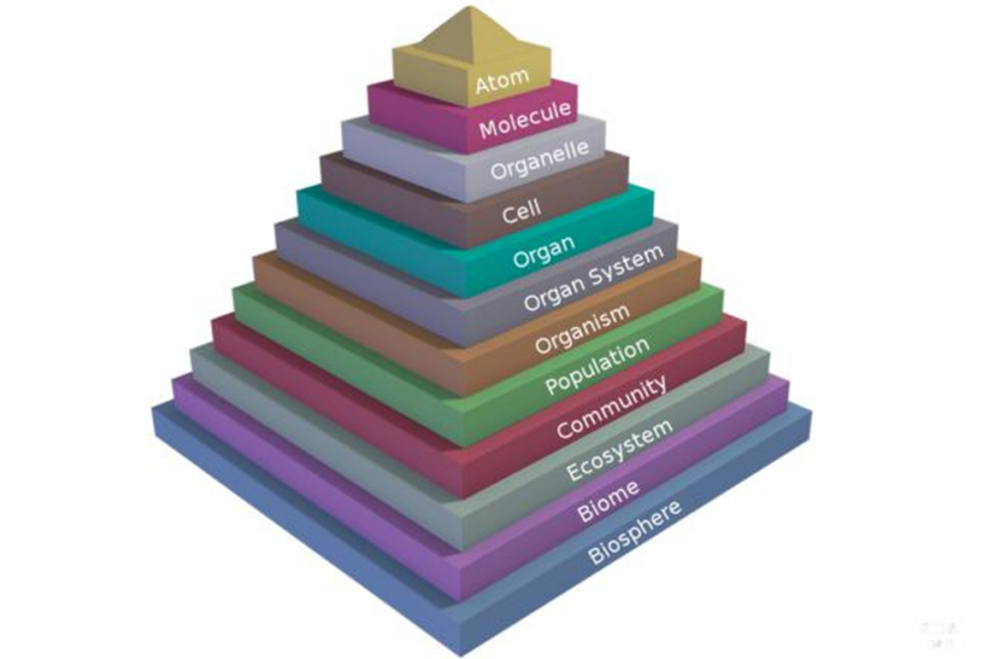
ECOLOGY GUIDED NOTES

What is ecology? –

Biotic factors =
Abiotic factors =
- People = ___________________
- Rocks = _________________
- Temperature = ___________________
- Water = _________________
- Plants = ___________________

What is tolerance of an organism? –

Population- Group of one species that can reproduce to form a fertile offspring.
Community-

Ecosystem- Communities + _________________________________________
Biosphere- The ____________________________ level of organization.

Habitat – “the address” -
Niche- “how it makes a living” –

What are some things that limit the ability of a species to grow uncontrolled? –

Producer- “autotrophs” –
Consumer – “Heterotrophs”
Types of consumers
- Carnivores-

- Omnivores-

- Saprophytes “decomposers”

- Herbivores

Symbiotic Relationships- How two organisms interact with each other.
- Commensalism

- Parasitism

- Mutualism

- Lichen-
Trophic Levels – each link in a food chain. Ex. Primary producer / primary consumer / secondary consumer.
- As you move up a food chain, the amount of available energy __________________ and the biomass _____________________.
“law of 10” – each level has _____________________ of the energy as the previous level.
- Ex. Primary consumers can get 10% of the original energy from the plants they eat.
  - Secondary consumers can get only 10% of that (1% of the original)

Biomagnification – ex. DDT and bald eagles –

Keystone species-
Energy ___________ through an ecosystem and Nutrients __________ in an ecosystem

Nutrient cycles-
Water
Evaporation-
Transpiration-
Condensation-
Precipitation-

Carbon- exists as _________ in the atmosphere.
Photosynthesis
Cellular Respiration

Nitrogen Cycle - ____________ of the atmosphere is made up of nitrogen (N2)
Nitrogen fixation- done by ______________________ - converts ______________________________________ into ammonium.
- Can also be done by ___________________________

Weather –
Climate-

Green house effect-

Population biology
4 factors that influence Density
- Immigration-

- Emigration-

- Density – Dependent Factors - _________________ Factors that have a larger effect on bigger populations. (Affect a population of 1 million more than a population of 1 thousand).

- Density Independent factors - _______________Factors that affect all population equally (Affect a population of 1 million the same as a population of 1 thousand)

Carrying capacity-

Exponential curve versus Logistic growth curve.

Ecological Succession
Primary – Begins in a place with ____________________.
- Pioneer Species
Secondary- Begins in a place with ___________.

Climax community-

Invasive species -

