Virtual Lab #1: Which color of light do plants grow best under?
Website: Search Glencoe photosynthesis virtual lab or enter the link below.
http://www.glencoe.com/sites/common_assets/science/virtual_labs/LS12/LS12.html

Hypothesis: Which color do you think will grow the tallest?

Data: Record the average plant heights for each type of plant under each lighting condition. (Include units)

Color | Radishes | Lettuce | Spinach
Red
Orange
Green
Blue
Violet

Graph: Create a bar graph with the appropriate labels, title, and units to show your data. Graph the average height for each color

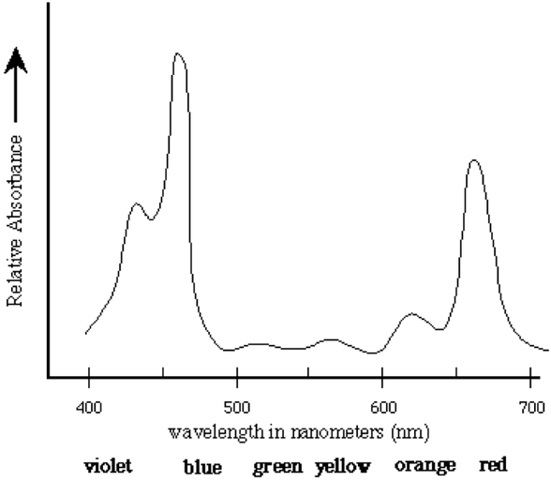
Questions:

- Which two colors of light grew the tallest?

- Does that relate to the chart above on the different colors absorbed by chlorophyll?

- The color that we perceive an object to be is actually the color (s) that is reflected (not absorbed) by an object. Using this, why do you think the plants grew the least under green light? (Hint: sunlight is absorbed to photosynthesis for energy)

- “White” light, or sunlight, is actually all of the colors on the visible spectrum together. Do you think a plant growing under white light would grow more or less than the ones under one specific light? Why?

