Name : ________________________________________________ Pd: __________

Viruses:
- __________ or __________ A viral genome can be ___________ or ____________.

- ______________________ Viruses that contain RNA are called _______?

- _________________________ Give an example.

- _________________________ Name of a virus that attacks bacteria?

- _________________________ Made up of protein only, cause of mad cow disease.

- _________________________ A protein coat around the genome of a virus

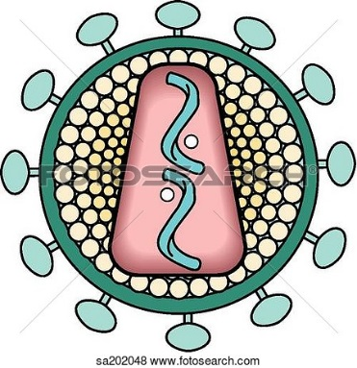
Label the following parts of a virus:

Capsid
Envelope
Genome
Spikes

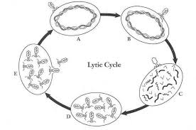
Label the steps of the lytic cycle; injection Of DNA , Attachment, cell bursting, replication, assembly.

